Mathematics


Items highlighted in yellow are tasks for you to complete
Items in Blue italics are help tips

Level 2 Mathematics Quiz

Question 1

0,051
2/3 20%

FRACTIONS
1/4 0,46

92%

What is the value of?
½ + (1/2 of ½) 1/2?
÷

(BE CAREFUL!)

Answer:

Question 2

Work out the area of the shaded quadrilateral

(Each square has sides of 1cm)

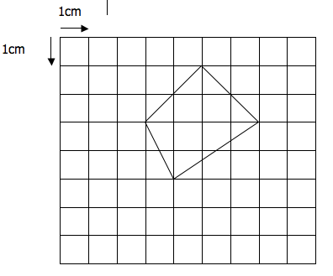

Answer:

Question 3
Fred’s Front Fence

Fred’s front fence consists of seven posts; each post is 3 metres from the next one. How long is the fence?

Answer:

Question 4

World
Cup



Simon scored three times as many goals as John in the 2003 Soccer season. Together they scored 28 goals. How many goals did Simon score?

Get this right and ask for your free soccer coaching gift
(Answers page Answer 12 gift)
Answer:

Question 5
$80.99
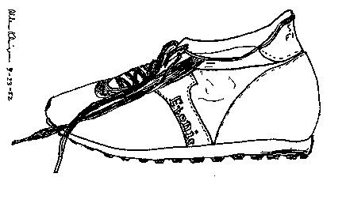
SALE

A pair of shoes usually costs $80.99
……………………
If they are reduced by 10%, what do they cost?

Answer:

Question 6
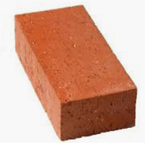

A BRICK
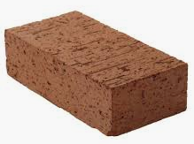
ANOTHER BRICK

Together, 2 bricks weigh 4kg.

How much does ¼ of one brick weigh?

Answer:

Question 7

The World’s Fastest Man

Usain Bolt (2019)

Although he can go a little faster, let us say that Usain Bolt
runs the 100m in exactly 10 seconds.

What is his speed in km/h (kilometres per hour)?

Answer:

Question 8



A plant grows 0.5cm on a cold day. It grows 1cm on a hot day. How much does it grow after 3 cold and 3 hot days?

Answer:

Question 9

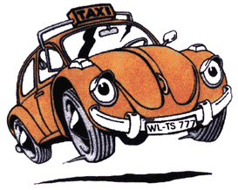


There are 15 taxis and 6 buses at the station. Each taxi holds one driver and 11 passengers. Each bus holds one driver and 42 passengers. How many people at the station?

Answer:

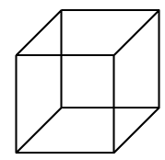
Question 10

What is the smallest number greater than 1 that is both a perfect square and a perfect cube?

Answer:

Question 11

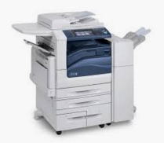

A photocopying machine makes 10 copies every 4 seconds. How many copies can it make in 6 minutes?

Answer:

Question 12

A piece of paper containing six joined squares is folded along the edges to form a cube. What is the letter on the face of the cube opposite the face labelled X?
Z
X
Y
W
V
U

Answer:

Need help just ask

